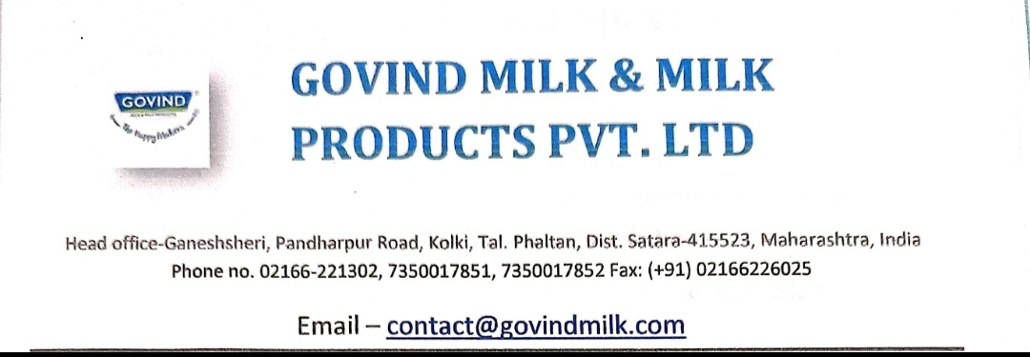
Date: 16.01.2021

To,
Principal,
JSPM’s- Jaywantrao Sawant Institute
Of Management & Research,
Hadapsar – Pune
Pin- 411028

Subject: Collaborative activities for research, Faculty exchange, Student exchange/ internship during the year 2021-20211

Dear Sir/Madam,
With subject above mentioned we are glad to inform you that our company will allow your students for internship on the basis of seats availability. Moreover we will conduct certain research activities for mutual benefit as and when required.

Thanking you

Yours sincerely


